4365

February 14, 2025

# It’s a Great Day to be a Saint!

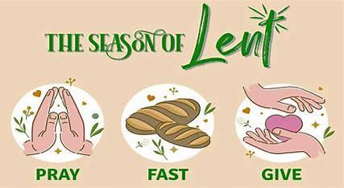

**The Lenten Season is understood as a journey. Journeys involve deliberate movement, not sitting around and waiting for things to happen. Our focus is on getting somewhere during the next 40 days.**

**Ash Wednesday is the beginning of our Lenten journey. In the modern Roman Catholic Church, the ashes are obtained by burning the palms used from the previous years Palm Sunday. These ashes are then applied in the shape of a cross on the forehead of each worshipper on Ash Wednesday. The ashes serve as a reminder of where we came from and are often accompanied with some variation of the words, “Remember that you are dust, and to dust you shall return.” Ash Wednesday is an obligatory day of fasting and abstinence, where only one full meal and no meat are to be consumed. This rule is set to be followed by people ages 18-59. Although Ash Wednesday is not a holy day of obligation, it is traditionally one of the most heavily attended non-Sunday masses of the liturgical year.**

**During the season of Lent, we prepare ourselves for the death and resurrection of Jesus. There are three pillars of Lent: prayer, fasting, and almsgiving. It involves not only what we are willing to give up, but what we are willing to take on.**

**Students will be attending Mass on Ash Wednesday. They will also be discussing the season of Lent in their classrooms and will be choosing what special things they will be doing to prepare themselves for the death and resurrection of Jesus. Students will also be attending Stations of the Cross on Fridays after 8:00 Mass.**

**February**

**Feb. 17** – No School (President’s Day)

**Feb. 20** – Kindergarten Open House 5:00-6:30

**March**

Mar. 4 – Mardi Gras Celebration/Bury the Alleluia

Mar. 5 – Ash Wednesday

Mar. 6 – Read Across America

Mar. 7 – No School

Mar. 8 – Dinner Auction

Mar. 11 – Home and School Meeting

Mar. 14 – End of 3rd Quarter

Mar. 21 – Musial Moments Assembly

Mar. 28 – Noon Dismissal/ PD Day

***Principal’s Corner***

***Congratulations to The Dunne family who were the winner of our early drawing for a free ticket. We currently have 206 tickets issued and 90 sold and returned. So…..KEEP SELLING THOSE TICKETS!!***

***There will be a Home and School meeting Tuesday, March 11 at 5:30 in the school cafeteria. Students will get a dress down pass for parents attending.***

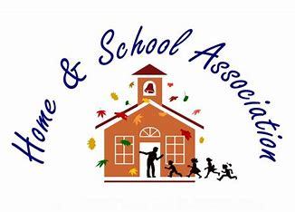

**Read Across America**

We will be celebrating Read Across American on Thursday, March 6th. Students can bring a pillow, blanket, and slippers to get cozy and read a good book.



Winter has definitely been interesting this year. From 2 degrees to 75 degrees, January brought us quite a variety.

Many times, the roads are unsafe at 7:00am, but by 8:00am they are drivable. If this happens to be the case at any given time, we will implement a delayed start. On delayed starts the doors will open at 8:30am for drop-off. However, students will not be counted tardy until after 9:00am.

And, as always, if it is unsafe for you to get your child to school, please stay home.

**Late Start**

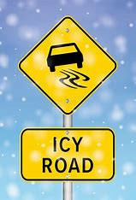

Please return Friday folders on **Mondays**. If you are sending money for lunch, aftercare, or tuition please put in the folder with name and what it is for.

Please call school if your child is ill or will be late.

Tardy bell rings at 7:50am. Students miss lunch count and important announcements when they are continuously late.

**Home and School Dinner Auction**

**The 31st Annual Dinner Auction will be held Saturday, March 8th. If you have not purchased your tickets you can still get them by contacting Marcia at the rectory. Thanks also to all who contributed to our school auction basket. With all of the donations we will be putting together a great basket. We are still working on the theme for our basket. We will send a picture in Remind when we have it all together.**

## 

## **Reminders**

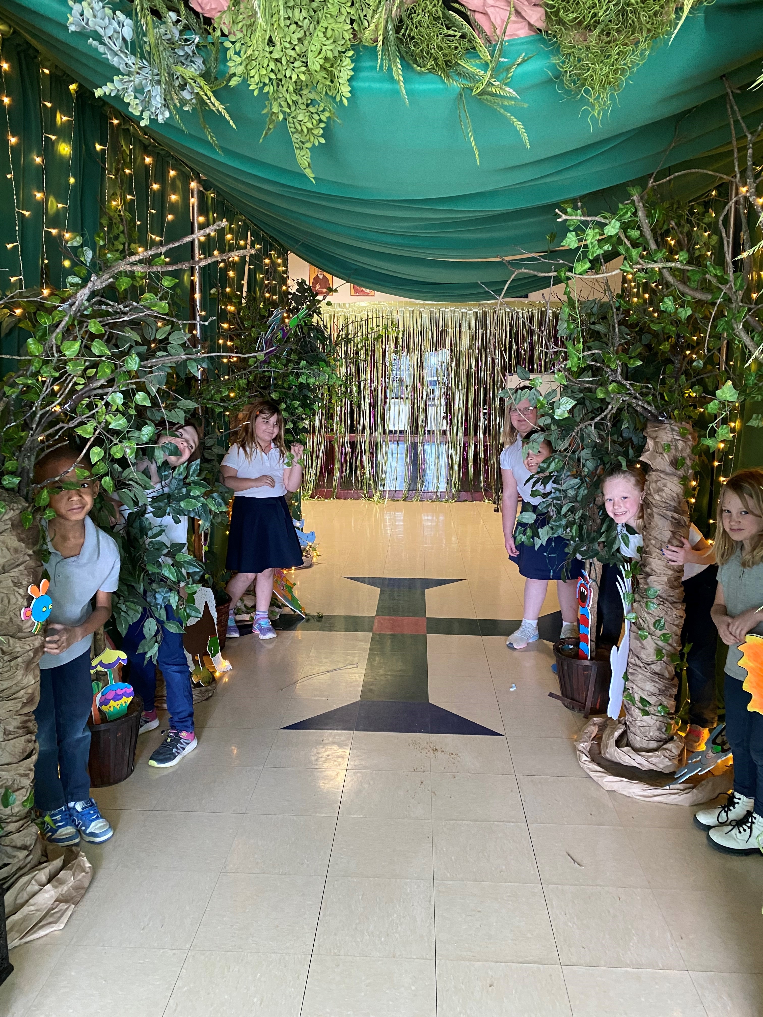

***Secretary***

*Angie Newbanks*

***Treasurer***

*Colleen Funke*

***Committee Chair*** *Aimee Bolte*

**Home and School**

Principal’s Corner

Page 2

Page 3

Principal’s Corner

**Mass Information**

Glo BINGO

What an amazing turnout we had for our 2nd annual glo bingo. Many thanks to our sponsors, donators of desserts, workers, and players. A special thanks to brad and Angie newbanks, mark and colleen Funke, and Brian and Jessica reed for all your hard work. Home and school profited a little over $8000.00 from this event!

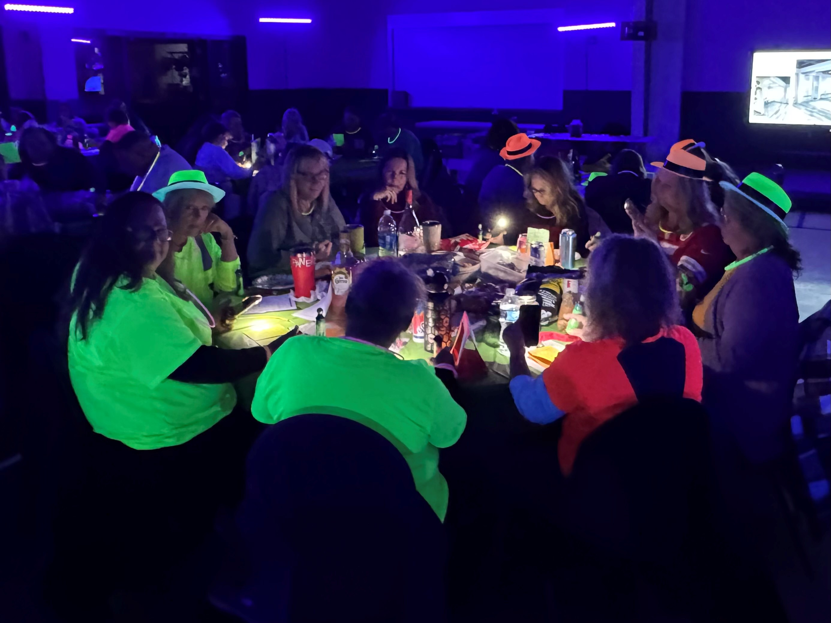

**REGISTRATION**

It’s that time of year again. We are beginning registration for the 2025-2026 school year. I love the excitement that this brings. We reached our goal of 80 students this year. Let’s go for 100 for next year!

Registration packets are being sent home today. IF they are returned by March 15th, we will waive the $25 family registration fee.

We are very excited to begin our plans for next school year and we hope that you will continue to be a part of our school family. 😊



All School Masses will be held on Thursday and Friday, with Adoration after Mass on Thursday. Masses begin at

8:00 am.

All K-8 students participate in the Mass on some level whether it be lecturing, reading the petitions, singing, or offertory on Fridays. Come join us!

There **will** be an 8:00am Mass at St. Anthony on Ash Wednesday, March 5th.

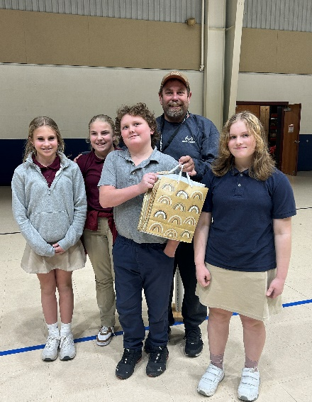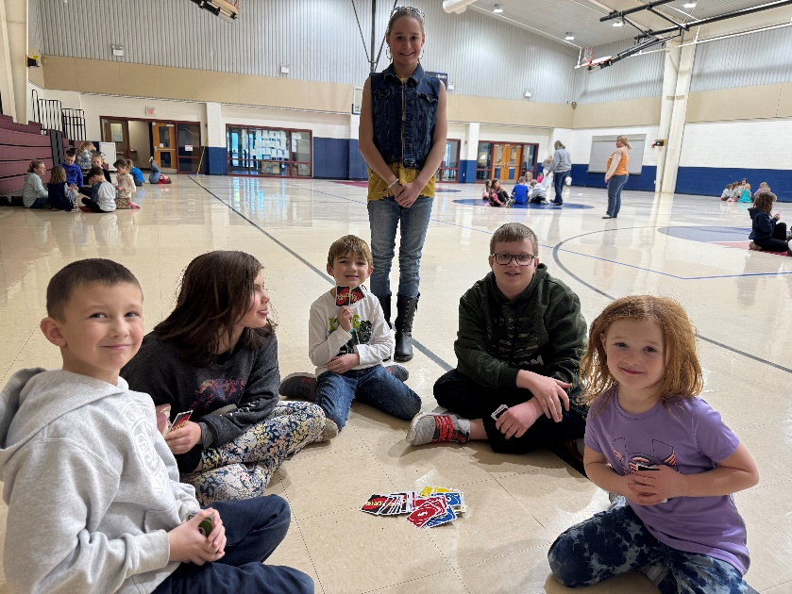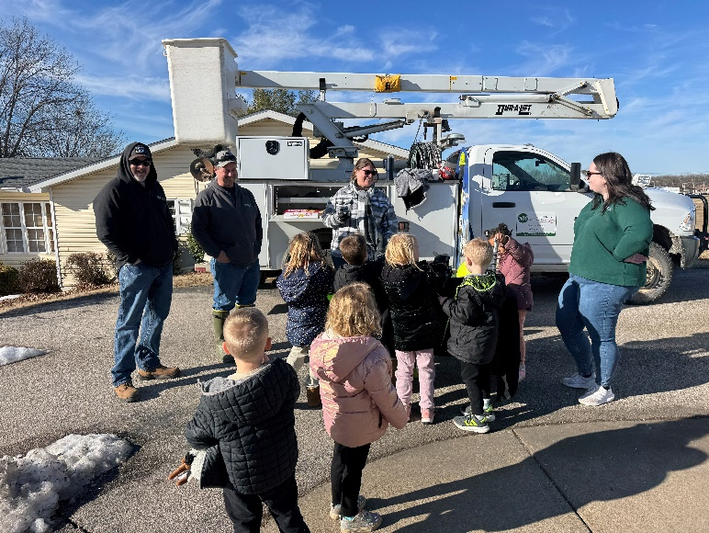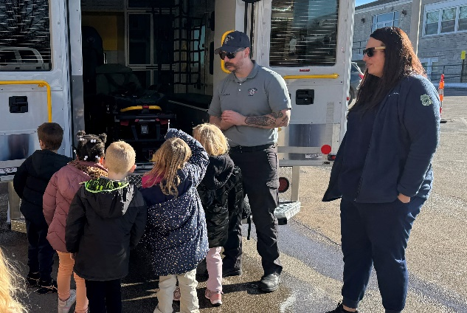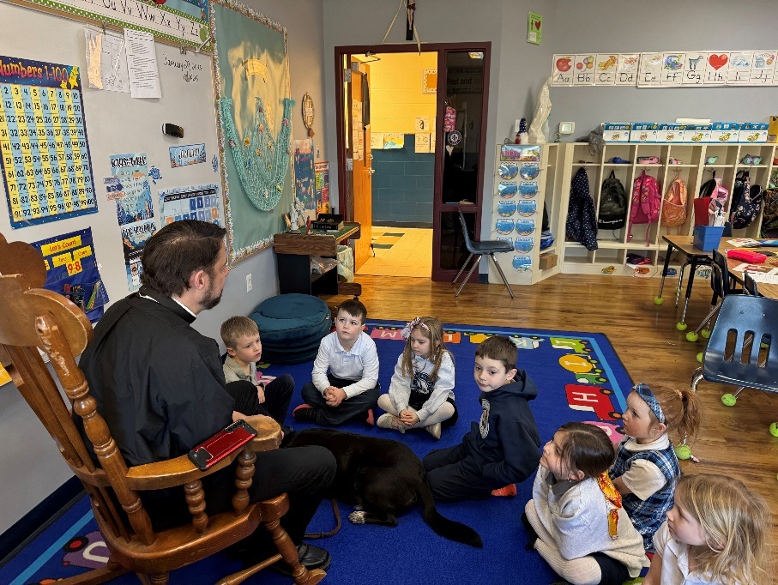

Principal’s Corner

**What’s Happening Around School**

Page 4